**Chapter 4**

**Osteoarthritis Detection and Grading Classification by Applying to Image Texture Analysis: Texture Based Approach**

**4.1 Introduction**

The introduction of the texture based approach for knee detection and knee OA detection are discussed in the chapter, while the shape based approach of the implementation of deep learning of Convolution Neural Network and shape based approach of the implementation of graph based of quad-tree techniques are illustrated in Chapter 5 and 6 respectively. In this chapter, there two main frameworks are discussed, first in the Section 4.2 taking about the framework of OA and normal detection based on texture analysis. For the second framework is illustrated in the Section 4.3, in this section the proposed work is to detected the OA stage with texture based analysis. The rest of this chapter is organized as: the Section 4.2 presented the texture based approach of OA detection by comparison of texture analysis techniques and Section 4.3 are presented about Knee X-ray Osteoarthritis Grading classification By Apply 10 Texture Descriptors**,** the two sections are illustrated in the following section.

**4.2 A Comparative Study of Texture Analysis Techniques for Osteoarthritis Detection**

**4.2.1 Introduction**

In this section, the applying of texture based approach for OA detection is considered. The main purpose of this section is to classify OA and normal case of 131 medical X-ray images. In order to analyse texture of images, the first important thing to do is to find the region of interest (ROI). In other words, ROI is the region that have own unique of each object that consider to be the main point to analyse the whole object or image. In the number of dataset 131 images, the dataset comprise of two groups: (i) OA images contains of 68 images and (ii) Non OA image contains of 63 images.

To be more specific, in this section ten image texture feature descriptors are applying to texture analysis whereby the ROI of each image in the dataset are separated into four ROIs, include: (i) Later Femur (LF), (ii) Medial Femur (MF), (iii) Lateral Tibia (LT), and (iv) Medial Tibia (MT). The four of ROIs segmentation was presented in detail in Chapter 3, Section 3.4 Region of Interest Segmentation and Enhancement. One of each four ROIs was applied to different ten texture descriptors that are presented in deep in Section 4.2.2 consider as the next section. The implementation of texture descriptors to four ROIs or sub-images produced a groups of feature space. In amount of feature spaces contain a lot of features, in these feature are comprise of different feature value and properties, so the selection of feature is very important to produce the good feature vector which this technique was called Feature Selection Technique. In similar vein, feature selection is a major technique to reduce feature dimensionality in feature spaces. In the study, five dissimilar feature selection techniques were applied that are discussed in Section 4.2.3 below. Make perfectly clear, a schematic of texture base approach is illustrated in Figure 4.1 below:

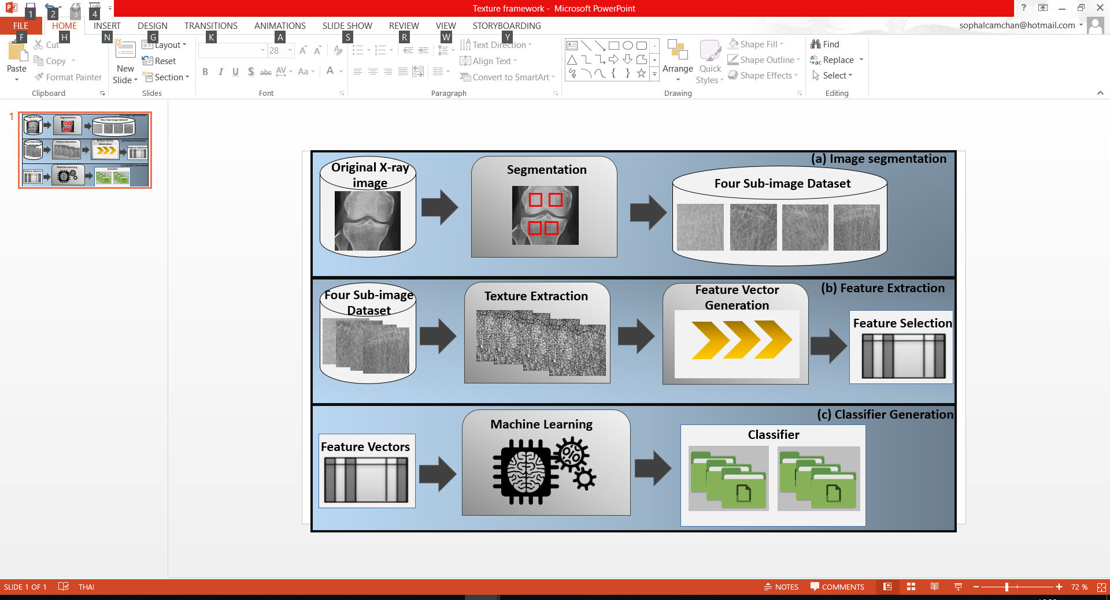

Figure 4.1 The OA detection framework.

With the reference to Figure 4.1, it can be seen that the texture based approach for OA screening detection comprises of three main processes: (i) image segmentation, (ii) Feature Extraction, and (iii) Classification Generation. The image segmentation of region of interest segmentation was discussed in Chapter 3 and will thus not discussed further in this chapter. When the ROIs were selected, then the implementation of feature extraction is to transform the selected pixel of region into the appropriate from suitable that better for classifier generation. The classifier generation is the applying of learning methods to feature vector that produced from feature extraction process (the second process of the framework). In this framework, nine popular of learning methods were applied in the classifier generation process, the nine learning methods were presented in Chapter 2.

In the second process of framework, feature extraction process consisted of sub-processes (as illustrated in Figure 4.1). The fundamental idea construct the texture base approach was to apply ten texture descriptor on four different ROIs. In this case, each ROI that applied with descriptor can produce a feature space which could be then apply with the feature vector representation of the form used by nine learning methods in this study that can make the feature extraction process consists of three sub-processes: (i) Texture Extraction, (ii) Feature Vector Generation, and (iii) Feature Vector Selection. Note that with the reference to Figure 4.1 the approach is illustrated in genera and, as will be pictured later in this thesis, similar approaches were used in Section 4.3 and the same as in Chapter 6.

The rest of this section are organized as follow: The information of texture descriptor techniques that used in the proposed work are presented in Sub-section 4.2.2. The detail of feature selection techniques are presented in Sub-section 4.2.3, while the classification is illustrated in Sub-section 4.2.4. Finally, the evaluation of study, the discussion of the study, and summary are presented in Sub-section 4.2.5, 4.2.6, and 4.2.7 respectively.

**4.2.2 Texture Descriptors**

In this subsection, the texture descriptors which were applied in the proposed framework is presented. There are 10 texture descriptors were applied include: (1) histogram feature, (2) Local Binary Pattern, (3) Completed LBP, (4) Rotated Local Binary Pattern, (5) Local Binary Pattern Rotation Invariant, (6) Local Binary Pattern Histogram Fourier, (7) Local Ternary Pattern, (8) Local Conﬁguration Pattern, (9) Haralick feature, and (10) Gabor ﬁlter feature descriptor, each of texture descriptor is present in following subsection:

1. Histogram feature

The gray image contain of histogram feature which is received by stage of the art histogram based feature. Three are six features are presented in the study include: (i) Mean, (ii) Variance, (iii) Skewness, (iv) Kurtosis, (v) Energy, and (vi) Entropy.

* Mean

(4.1)

Where   
 P(j) is the probability of j, P(j) can be defined as the equation below:

(4.2)

M is the block number and H(j) is the histogram function.

* Variance

(4.3)

* Skewness

The Skewness is written in the equation below:

(4.4)

Where

σ is the standard deviation which is the square root of the variance presented in equation 4.3.

* Kurtosis

(4.5)

* Energy

(4.6)

* Entropy

(4.7)

1. Local Binary Pattern

With the reference to work [14], LBP was us to label the pixel which was implemented thresholding to the neighborhood of each pixel come along with the output presented as the binary number. In Figure 4.2 is illustrated the work of LBP operation:



Figure 4.2 LBP Operator

For LBP at pixel(xc, yc) can be define as the equation below:

(4.8)

Where

P presents as the pixel surrounded in the circle neighborhood.

R presents as the radius of circle.

ic and ic present as the gray-level of the center point.

S(x) presents as the function which S(x) is defined as:

(4.9)

In addition, there are many of texture descriptor which is improve from LBP techniques. In this study, completed local binary, rotated local binary pattern and local binary pattern histogram fourier are presented in the study.

1. Completed Local Binary Pattern

In work [15], Completed Local Binary Pattern (CLBP) of a local region can be defined by 2 factors: (i) a center pixel and (ii) a local difference sign-magnitude transform (LDSMT). With the reference to the study purpose, LDSMT has been focused. LDSMT consist of two elements: (i) the diﬀerence signs (CLBP S), and (ii) the diﬀerence magnitudes (CLBP M).

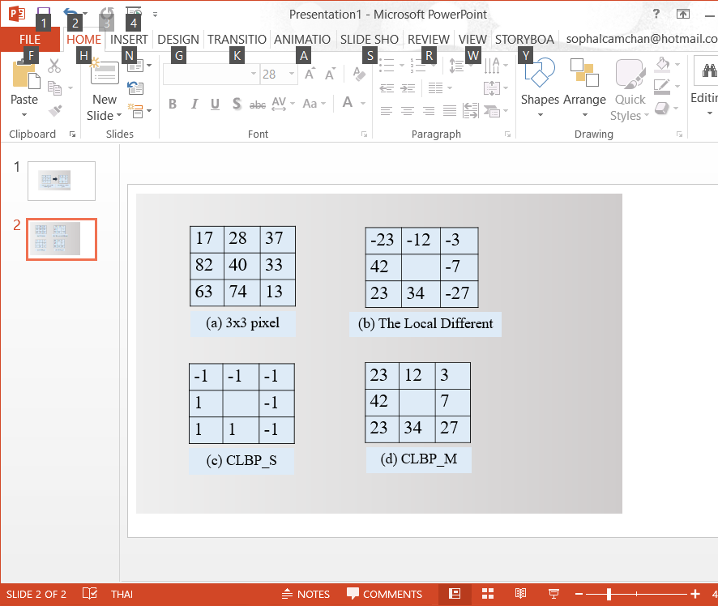

Figure 4.3 The operation of CLBP

1. Rotated Local Binary Pattern

For Rotated Local Binary Pattern (RLBP) [16] or Dominated Rotated Local Binary Pattern (DRLBP) [17] is a technique of LBP rotation around the center pixel of object. In order to get the deep understand of RLBP work, the Figure 4.4 is illustrated the process of RLBP work:

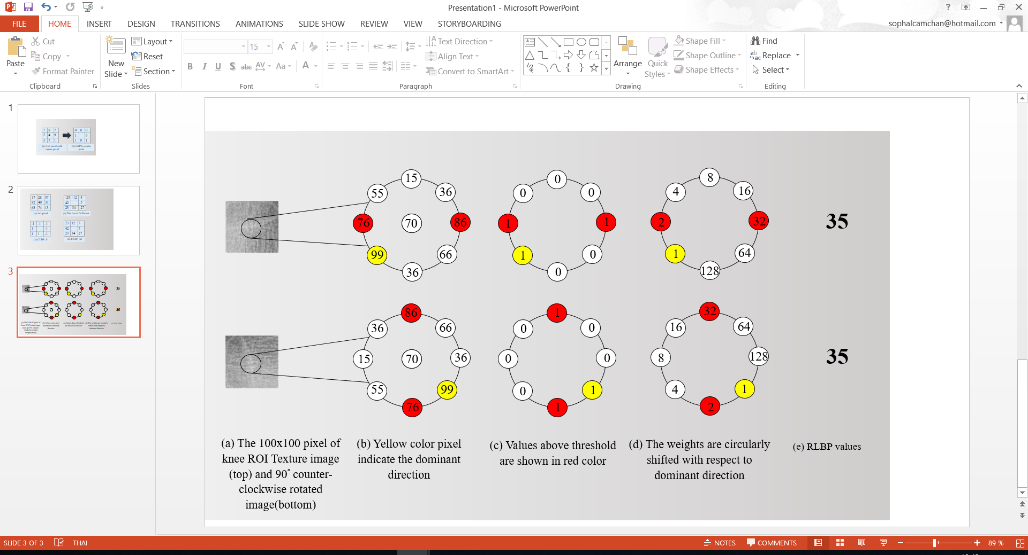

Figure 4.4 The Operation of RLBP

Beside the operation was illustrated in figure 4.4, RLBP can be defined as the equation below:

Where

(4.10)

D is dominant direction in a neighborhood, D can be formed as the equation:

(4.11)

1. Local Binary Pattern Rotation Invariant

The Local Binary Pattern Rotation Invariant or LBPri is presented in this subsection. LBPri is another one technique of LBP that implemented of rotation invariant feature. With the reference to Equation LBPequation, LBP operation can produce of output with 2P different values, mean that the 2P different binary cab be represented by the P pixels of the neighbor set pixel. With the respect to study purpose, LBPri have applied to the pixel with 8 neighbor pixels that represented as the equation below:

(4.12)

1. Local Binary Pattern Histogram Fourier

In this subsection, the Local Binary pattern Histogram Fourier (LBP-HF) is illustrated. LBP=HF consider as a rotation-invariant feature descriptor which is improves from the LBPs uniform. LBP-HF is defined by the first computing of histogram non-invariant of LBPs to the whole object or region, father that the invariant feature of the histogram construct rotationally. The main used of LBP-HF is formed by statistic features which is used to calculate the global features of the LBP histogram by Fast Fourier Transform (FFT). In this case, LBPri consider as the subset of LBP-HF. The implementation of LBP-HF is represented as the Figure 4.5 below:



Figure 4.5 The Implementation of LBP-HF

If α = 45°, local binary pattern

10001010 🡺 00010101

00010101 🡺 00101010, …,

11111000 🡺 11110001, …,

At the same time, if α= K * 45°, so, the pattern have to be circularly rotated with K steps.

1. Local Conﬁguration Pattern

Local Configuration Pattern (LCP) is considered as the rotation invariant image feature description technique. In the information architecture feature of images, LCP separated image features into two different groups: (i) local structure information and (ii) microscopic configuration or MiC. There are two groups of information architecture include: (i) image configuration and pixel-wise interaction relationship [51]. In local structure information is definitely related to the basic of LBP operation, while in microscopic configuration used for searching the feature of microscopic configuration information. In Figure 4.6 is illustrated the implementation of LCP to local structure and MiC concept:

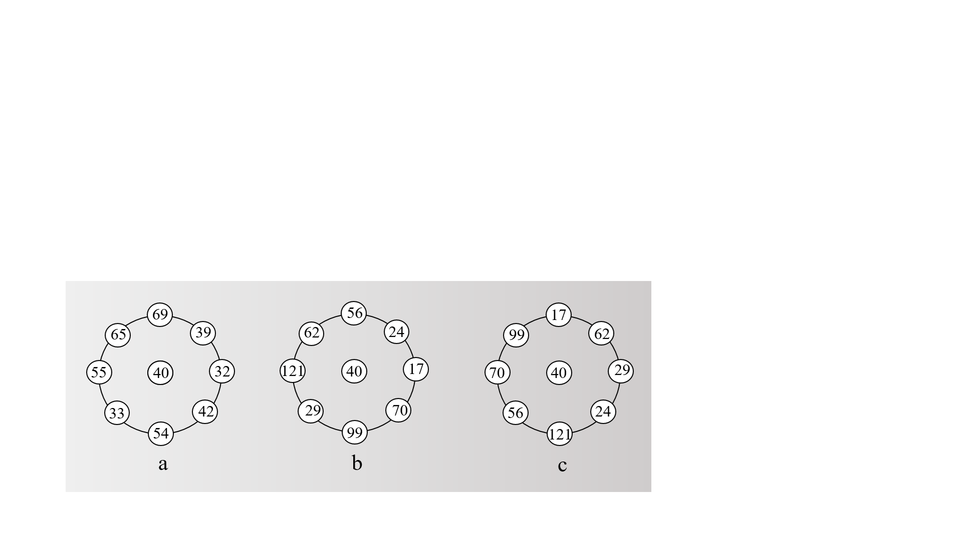

Figure 4.6: The Concept of LCP

With the reference to Figure 4.6, in figure 4.6(a) and 4.6 (b) are the same in case of pattern type as LBP (all neighbor pixel compare to center pixel value). On the contrary, figure 4.6 (a) and 4.6(b) are different in case of LBP with local invariant information, while Figure 4.6(b) and 4.6(c) are the same because of the same value of invariant. For figure 4.6(b) and figure 4.6(c) are different if consider in term of MiC. MiC is based on textural properties which can be formed as the equation below:

(4.13)

Where

gc  is the intensity of center pixel values

gj is the intensity of neighbored pixel values

aj(j0, …, P-1) are the weighting parameters relation with gj

E(aj) is the reconstruction error regarding model parameters of aj

1. Local Ternary Pattern

Local Ternary Pattern (LTP) is described in this subsection. LTP is one of the development of LBP technique that used to analyse the center pixel of ic. With the reference to equation LBPequation, S(x) have only two values, but when applied with LCP the S(x) is instead of 3 values function St(u,ic,t) as the following equation:

(4.14)

1. Haralick feature

In this subsection, Haralick which is calculated from the Gray-Level Com-0ccurrence Matrix (GLCM) presents in this subsection. GLCM is presented as one of the most common techniques to represents the image texture. In this case, Haralick which is measured from the statistic of the basic GLCM is divided into 14 feature as the following:

* Angular Second Moment (ASM)

(4.15)

* Contrast

(4.16)

* Correlation
* Variance

(4.18)

(4.17)

* Inverse Difference Moment (IDM)

(4.19)

* Sum Average

(4.20)

* Sum Variance

(4.21)

* Sum Entropy (f8)

(4.22)

* Entropy

(4.23)

* Different Variance

(4.24)

* Different Entropy

(4.25)

* Information Measure of Correlation 1 (IMC1)

(4.26)

Where

HXY is the value of Entropy

HX and HY are the entropy of Px and Py

(4.27)

* Information Measure of Correlation 2 (IMC2)

(4.28)

Where

(4.29)

* Maximum Correlation Coefficient (MCC)

(4.30)

1. Gabor ﬁlter feature

Gabor filter feature descriptor is presented in this subsection, Gabor is known as one of the texture extraction techniques that used analyse image feature texture based on specific frequency and specific direction. Gabor filter banks consist of frequencies, orientations and smooth parameters of Gaussian envelope. Gabor filter banks at pixel (x, y) is defined as the equation below:

(4.31)

Where

andpresent as the center frequency of x and y direction

σx and σy present as the standard of the Gaussian function along x and y direction.

**4.2.3 Feature Selection**

In this section feature selection is described. Feature selection consider as the main process in the research study in order to make a feature vector which is very important for the classification process. The main use of feature in the research study is to reduce data dimensionality for making the feature vector. In the study, there are five feature selection techniques are applied, including: (i) Correlation-based Feature Selection (CFS), (ii) Chi-Square, (iii) information gain, (iv) Gain Ration, and (v) Relief feature selection.

1. Correlation-based Feature Selection

Correlation-based feature selection is a techniques used to reduce the feature space that applied a heuristic search for evaluation the worth of feature subsets. In work [52] and [53] illustrated that CFS used the heuristic search for calculation the evaluation of feature subsets that based on the hypothesis **“Good feature subsets contain features highly correlated with the classiﬁcation, yet uncorrelated to each other”**. Inorder to reduce the feature space, CFS used Symmetric Uncertainty. The fooling equation is defined as the Symmetric Uncertainty equation of two nominal attributes A and B:

Where

(4.32)

H is the function of entropy

With the reference to Equation 4.32, CFS can be forms as the equation below:

(4.33)

Where

C is the class of the feature

(Ai,Aj) is the indicates a pair of attributes

1. Chi-square

Chi-square is used to measure the relationship of dependency between a feature and a class [54]. Chi-square is represented as χ2 symbol and defined as the equation below:

(4.34)

Where

Oij represent as the observed frequency

Eij represent as the expected frequency

1. Information Gain

Information gain or IG is consider as one of the popular feature selection techniques. The implementation of IG is for selecting the test attribute at each node. IG can measure the number of information in bits to the class prediction while the available information present as a feature and class distribution [55]. For instant, if IG of a feature s directly related to a collection aspects B, thus IG can be represented as the equation below:

(4.35)

Where

Values(s) presents as the set of all possible feature values s

|Bv| presents as the cardinality to the subset of class related to feature s

|Bt|presents as the cardinality to theset of aspects belonging to feature s

1. Gain Ration

Gain ration is presented in this subsection, the improvement of correction from IG is consider as gain ration technique. The implementation of decision tree in IG for one reason is to select the test attribute of each node [56]. Thus, the applying of GR to make IG better performance by choosing an attribute by token number and size of branches. In other words, GR is implemented to IG in order to reduce the bias of IG on each branch. GR is written as the equation below:

(4.36)

1. Relief

Relief feature is the last technique is presented in this subsection. Relief first introduce in work [58]. Relief is the weight based algorithm that the related features are consider as the one who has a better distinction between the classes [57]. In order to understand the relief, a sample of dataset is selected, the nearest neighboring sample that belongs to the same class is called ‘**Near-hit’**. On the contrary, the nearest neighboring sample that belongs to the opposite class is called ‘**Near-miss**’. The relief measure these two weights: (I) Near-hit and (ii) Near-miss. In addition, all reiterations of M times, relief takes the feature vector of X that belong to random sample of Near-hit and Near-miss. After M iteration has gone, relief separates each item of the weight vector by M, thus, the relevance vector is created. Finally, the selected feature gets from the features that have relevance value greater than a threshold T value.

**4.2.4 Classification**

The classification of Knee OA and non OA is presented in this section. Classification in the study is refer to the implementation of learning approach that can make a better result of OA and non OA classification. There are nine learning algorithm are applied in the study, include: (i) Decision Tree (C4.5), (ii) Binary Split Tree, (iii) Average One-Dependence Estimators (AODE), (iv) Bayesian Network (BN), (v) Naïve Bayes, (vi) Support Vector Machine, (vii) Logistic Regression, (viii) Sequential Minimal Optimization (SMO), (ix) Neural Network Back Propagation. All these nine learning algorithm was presented in Chapter 2 section 2.4.3 Classification Learning Methods.

**4.2.5 Evaluation**

In the evaluation process, the purpose of evaluation was used to produce the evidence that OA condition can be detected efficiency by applying the proposed framework. In this section, the four sets of experiment were presented with the reference to the objectives of comparing and choosing the most efficient results for the bellow criteria:

1. To demonstrate the most appropriate region of interests (ROIs) to four sub-images presented in Chapter 3
2. To demonstrate the most appropriate texture descriptors to texture descriptors presented in sub-section 4.2.2
3. To identify the most appropriate feature selection with the respect to feature selection in sub-section 4.2.3
4. To identify the most appropriate learning algorithm with the reference to nine learning algorithm discussed in Chapter 2, sub-section 2.4.3

Each of objection was illustrated in the following four criteria. Ten Cross validation was implemented in this study. To this end, the discussion of the each criteria for the result comparison is presented in the bellowing subsection: (note that the best result was measured by AUC parameter):

1. **Region of Interest results**

The best result of each sub-image is presented. The four sub-image: (i) Medial Femur (MF), (ii) Lateral Femur (LF), (iii) Medial Tibia (MT), and (iv) Lateral Tibia (LT). The best performance of each ROI is illustrated in Table 4.1 below:

|  |  |  |  |  |  |  |
| --- | --- | --- | --- | --- | --- | --- |
| **ROI** | **AUC** | **AC** | **SN** | **SP** | **PR** | **FM** |
| MF | 0.884 | 0.794 | 0.794 | 0.792 | 0.794 | 0.794 |
| **LF** | **0.912** | **0.832** | **0.832** | **0.832** | **0.832** | **0.832** |
| MT | 0.895 | 0.802 | 0.895 | 0.802 | 0.895 | 0.802 |
| LT | 0.883 | 0.809 | 0.809 | 0.809 | 0.809 | 0.809 |

Table 4.1. Region of Interest best results.

In Table 4.1 it shown that Literal Femur (LF) is the most appropriate one amount of four sub-image of texture analysis for OA detection come with the highest value of AUC of 0.912, while the second highest appropriate went to Medial Femur (MF) with the AUC value of 0.895. With the reference to Table 4.1, it should be suggested that Lateral Femur is first selecting area for texture analysis of OA detection.

1. **Texture Descriptor results**

The best result of each texture descriptor is presented. With the respect to Table 4.1 was shown that lateral femur is the most appropriate region of interest, thus the best result of each texture descriptor was received from the implementation of LF ROI. The best result of 10 texture descriptors (present in Sub-section 4.2.2) are illustrated in Table 4.2 below:

|  |  |  |  |  |  |  |
| --- | --- | --- | --- | --- | --- | --- |
| **Texture Descriptor** | **AUC** | **AC** | **SN** | **SP** | **PR** | **FM** |
| Histogram | 0.757 | 0.695 | 0.695 | 0.69 | 0.695 | 0.693 |
| **LBP** | **0.912** | **0.832** | **0.832** | **0.832** | **0.832** | **0.832** |
| CLBP | 0.882 | 0.763 | 0.763 | 0.762 | 0.763 | 0.763 |
| RLBP | 0.895 | 0.809 | 0.809 | 0.81 | 0.81 | 0.809 |
| LBPri | 0.812 | 0.771 | 0.771 | 0.771 | 0.771 | 0.771 |
| LBP-HF | 0.773 | 0.71 | 0.71 | 0.717 | 0.71 | 0.709 |
| LTP | 0.816 | 0.756 | 0.756 | 0.761 | 0.763 | 0.755 |
| LCP | 0.783 | 0.725 | 0.725 | 0.724 | 0.725 | 0.725 |
| Haralick | 0.695 | 0.664 | 0.664 | 0.67 | 0.672 | 0.662 |
| Gabor | 0.883 | 0.786 | 0.786 | 0.786 | 0.786 | 0.786 |

Table 4.2: Texture descriptor best results.

With the reference to Table 4.2, it can be seen that Local Binary Pattern or LBP is consider as the best performance in texture descriptor for OA detection work combine with LF ROI can produce the best AUC value of 0.91. For the second best texture descriptor performance went to Rotated Local binary Pattern or RPBL which one of the improvement techniques from LBP, the best result of RLBP produced the second highest of ACU value of 0.895 in case of texture analysis of OA detection amount of four ROIs. Based on Table 4.2, it can suggest that LBP is the first choice for using in OA detection and the second choice went to RBLP. On the other hands, Haralick feature produced the lowest result of AUC compare to other texture descriptors. It can be suggested that Haralick is the last choice in this case.

1. **Feature Selection Techniques results**

The best feature section result of each technique for OA detection is presented. Based on Table 4.1 and 4.2 shown that LF is the best selected ROI and LBP is the best result of texture descriptor for knee screening OA detection study, thus in this sub-section the third objective of evaluation is presented. There are five well-know of feature selective are presented in Sub-section 4.2.3 was applied in this evaluation, and the best result of each techniques is illustrated in Table 4.3:

|  |  |  |  |  |  |  |
| --- | --- | --- | --- | --- | --- | --- |
| **Texture Selector** | **AUC** | **AC** | **SN** | **SP** | **PR** | **FM** |
| **CFS** | **0.912** | **0.832** | **0.832** | **0.832** | **0.832** | **0.832** |
| Chi-Square | 0.699 | 0.687 | 0.687 | 0.687 | 0.687 | 0.687 |
| Gain Ratio | 0.709 | 0.687 | 0.687 | 0.687 | 0.687 | 0.687 |
| Information Gain | 0.699 | 0.687 | 0.687 | 0.687 | 0.687 | 0.687 |
| Relief | 0.699 | 0.679 | 0.679 | 0.674 | 0.681 | 0.677 |

Table 4.3: Feature Selection Techniques best results.

In Table 4.2 it can be seen that Correlation Based Feature selection of CFS is the best Texture selectors which applied with LF and LBP to produce the highest value of AUC at 0.912. Gain ration is the second best of texture selector which can produce the value of AUC at 0.709. On the contrary, Chi-square, Information gain and relief produce the same value of AUC with the value of 0.699. In term of AUC value, it can be suggested that CFS is the first texture selector for knee OA detection applied with LF ROI and LBP texture analysis technique.

1. **Classification Algorithm results**

The learning method were presented in Chapter 2 considered as the classification algorithm in the fourth objective of the evaluation. The best result of classification which come each technique from nine learning methods is presented in Table 4.4 below:

|  |  |  |  |  |  |  |
| --- | --- | --- | --- | --- | --- | --- |
| **Learning Method** | **AUC** | **AC** | **SN** | **SP** | **PR** | **FM** |
| C4.5 | 0.757 | 0.779 | 0.779 | 0.78 | 0.78 | 0.779 |
| Binary Split Tree | 0.766 | 0.74 | 0.74 | 0.736 | 0.742 | 0.739 |
| AODE | 0.896 | 0.809 | 0.809 | 0.804 | 0.809 | 0.809 |
| **Bayesian Network** | **0.912** | **0.832** | **0.832** | **0.832** | **0.832** | **0.832** |
| Naïve Bayes | 0.903 | 0.817 | 0.817 | 0.816 | 0.817 | 0.817 |
| SVM | 0.715 | 0.718 | 0.718 | 0.711 | 0.72 | 0.715 |
| Logistic Regression | 0.904 | 0.84 | 0.84 | 0.844 | 0.847 | 0.839 |
| SMO | 0.771 | 0.771 | 0.771 | 0.771 | 0.771 | 0.771 |
| Neural Network Back propagation | 0.851 | 0.771 | 0.771 | 0.77 | 0.771 | 0.771 |

Table 4.4: Learning Method Algorithm best results.

With the respect to Table 4.4, it shown that Bayesian Network is the best learning method that can produced the highest value of AUC with the value of 0.912, while the second best learning method went to Logistic regression with the AUC value of 0.904. In contrast, support vector machine is the lowest learning method for selection in case of OA detection due to the production of AUC value of 0.715 that considered as the lowest AUC value amount of learning methods applied in the study. In short, it should be suggested that the applying of Bayesian network to LF RI, LBP texture descriptor, and CFS feature selection approach produced the highest AUC value of 0.912.

**4.2.6 Discussion**

The overall classification result of OA detection presented in the previous section, section 4.2.5 illustrated that the proposed texture based approach, using ten different texture descriptors for texture analysis to dissimilar four ROIs, performed well to the knee X-ray image dataset. The main finding from the experiment were divided into four sets:

1. Amount of four sub-image, the performance of LF is better than other sub-images performance that can make the classification is more effective. In term of AUC value measure, the report of evaluation found that LF ROI produce AUC value of 0.912 considered as the highest value.
2. The best result of classification performance in term of texture descriptors mechanism for X-ray image dataset, was obtained by applying local binary pattern (LBP), followed by rotated local binary pattern (RLBP), while haralick is the last texture descriptor amount of ten texture descriptor in the experiment.
3. The most appropriate feature selection mechanism in the experiment of the study was obtain by correlation based feature selection (CFS) with the highest AUC value of 0.912, followed by Gain Ration with the AUC value of 0.709, and then three feature selection mechanism: (i) Chi-square, (ii) Information Gain, and (iii) Relief that all these three method produced the same AUC value of 0.699.
4. The best performance of leaning method identified from the reported evaluation were: (i) Bayesian Network, (ii) Logistic Regression, and (iii) Naïve Bayes, which considered as the top three of learning method with the AUC value of 0.912, 0.904, and 0.903 respectively, thus Bayesian network produced a slightly better overall performance than Logistic Regression, while Naïve Bayes almost equal to Logistic regression classifier.

**4.2.7 Summary**

In short, in this chapter the proposed approach to OA detection from knee X-ray image dataset. The proposed approach is based on textures analysis, the applied of ten different texture descriptor techniques to analyse on four dissimilar sub-image. When the applying of Texture descriptor on sub-image was finished, a group of feature space was created, thus five different feature selection techniques were applied that considered as a vital rule to select feature vectors for use in nine dissimilar classifier generation techniques. The reported evaluation indicated that highest value of AUC and accuracy of classification were obtained by using of LB ROI, LBP texture descriptor, CFS feature selection, and Bayesian Network. In the following section an alternative of knee OA grading classification with texture analysis is described.

**4.3 Knee X-ray Osteoarthritis Grading classification By Apply 10 Texture Descriptors**

**4.3.1 Introduction**

In this section, the implementation of texture based approach for OA stages classification is illustrated. The main purpose of this section is to classify of OA stages that comprise of five grade as mentioned in Chapter 3. In the OA stages classification study. The dataset was separated into five groups as mentioned in Table 3.1. The first important thing to anlyse the image is to define ROI of image for texture analysis

In particular, in this section ten image texture feature descriptors are applying to texture analysis whereby the ROI of each image in the dataset are separated into four ROIs, include: (i) Later Femur (LF), (ii) Medial Femur (MF), (iii) Lateral Tibia (LT), and (iv) Medial Tibia (MT). The four of ROIs segmentation was presented in detail in Chapter 3, Section 3.4 Region of Interest Segmentation and Enhancement. One of each four ROIs was applied to different ten texture descriptors that was presented in detail in Section 4.2.2. The implementation of texture descriptors to different four ROIs or sub-images produced a groups of feature space. The feature selection technique play a vital rule to reduce the dimensionality of feature space. In the study, five different feature selection techniques were applied that was discussed in Section 4.2.3.To be more specific, the framework of OA stages classification is illustrated in the Figure 4.7 below:

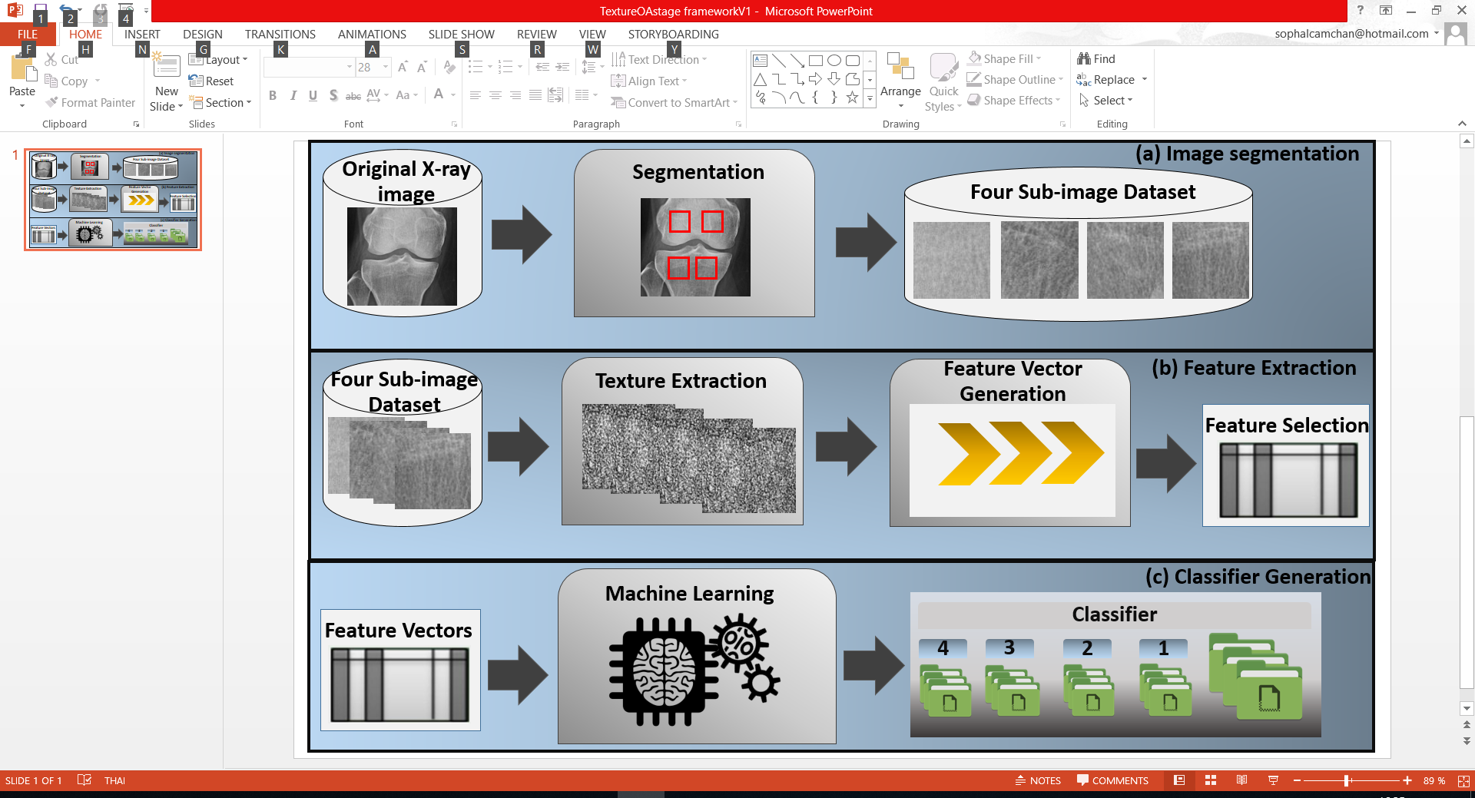

Figure 4.7 The framework of OA stages detection

From Figure 4.7 it can be seen that there are three main process of the framework include: (i) image segmentation, (ii) feature extraction, and (iii) classifier generation.

From the first process till the last process were presented OA detection study in Section 4.2.1. However, the different of the framework in OA detection and the frame of OA stage detection are the different output and input of dataset group to the study.

**4.3.2 Texture Descriptors**

There are ten texture descriptors was applied in the study of OA stage detection. Texture descriptor in this subsection are the same as texture which was presented in Subsection 4.2.2.

**4.3.3 Feature Selection**

In this study, the feature selection of correlation based feature selection technique is applied to the study of OA stages detection. The correlation based feature selection or CFS was presented in subsection 4.2.3.

**4.3.4 Classification**

There are nine learning algorithm are applied for OA stages detection include: (i) Decision Tree, (ii) Binary Split Tree, (iii) Average One-Dependence Estimators, (iv) Bayesian Network, (v) Naïve Bayes, (vi) Support Vector Machine, (vii) Logistic regression, (vii) Sequential Minimal optimization, and (ix) Back Propagation Neural Network. All of the nine learning methods were presented in Chapter 2.

**4.3.5 Evaluation**

The OA stages classification is presented in this section, the purpose of this section was to presented the evidence that conclude that OA stage grading is easily to detected by using he proposed approach. With the respected to Section 4.2, the evaluation of section 4.2 shown that CFS mechanism is the most efficient feature selection techniques. Thus in this evaluation, there are 3 sets of experiment are discussed with the reference to three objectives as the following:

1. To identify the most appropriate region of interests (ROIs) to four sub- images presented in Chapter 3 section 3.4
2. To demonstrate the most appropriate feature texture descriptor techniques with the reference to texture descriptors described in subsection 4.2.2
3. To demonstrate the most appropriate learning methods with the respect to nine learning method mentioned in Chapter 2 subsection 2.4.3

In this evaluation, Ten Cross-Validation (TCV) was used, the three objectives were declared above are presented in the following subsection:

1. **Region of Interests best result**

The best performance of each ROI is presented. In the study, there are four ROI: (i) Medial Femur (MF), (ii) Lateral Femur (LF), (iii) Medial Tibia (MT), and (iv) Lateral Tibia (LT). The best result of each ROI is illustrated in Table 4.5 below:

|  |  |  |  |  |  |  |
| --- | --- | --- | --- | --- | --- | --- |
| **ROI** | **AUC** | **AC** | **SN** | **SP** | **PR** | **FM** |
| MF | 0.822 | 0.569 | 0.569 | 0.849 | 0.580 | 0.553 |
| LF | 0.816 | 0.585 | 0.585 | 0.849 | 0.618 | 0.577 |
| **MT** | **0.871** | **0.654** | **0.654** | **0.907** | **0.691** | **0.658** |
| LT | 0.828 | 0.592 | 0.592 | 0.833 | 0.635 | 0.658 |

Table 4.5. Region of Interest best results.

In Table 4.5 it can be seen that Medial Tibia (MT) is the best ROI for OA stages detection with the highest value of AUC of 0.871. On the other hands, LF produce the lowest value of AUC value of 0.816. Finally, it can be suggested that medial tibia region is worked well for OA stages detection in case of texture analysis, while lateral femur is considered as the last choice for ROI selection for OA stages detection.

1. **Texture Descriptor best results**

The best performance of feature section result o for OA stages detection in the study is illustrated. With the reference to Table 4.5 illustrated that MT is the best performance of ROI for knee OA stages detection study, thus the best texture descriptors consider as the second objective of the evaluation in OA stages detection study is presented. There are 10 well-know of texture descriptors are presented in Sub-section 4.2.2 were applied in this evaluation, and the best result of each algorithm is shown in Table 4.6:

|  |  |  |  |  |  |  |
| --- | --- | --- | --- | --- | --- | --- |
| **Texture Descriptor** | **AUC** | **AC** | **SN** | **SP** | **PR** | **FM** |
| Histogram | 0.647 | 0.496 | 0.496 | 0.776 | 0.418 | 0.408 |
| **LBP** | **0.871** | **0.654** | **0.654** | **0.907** | **0.678** | **0.658** |
| CLBP | 0.789 | 0.569 | 0.569 | 0.836 | 0.58 | 0.553 |
| RLBP | 0.817 | 0.585 | 0.585 | 0.856 | 0.578 | 0.559 |
| LBPri | 0.682 | 0.477 | 0.477 | 0.815 | 0.478 | 0.451 |
| LBP-HF | 0.682 | 0.438 | 0.438 | 0.801 | 0.418 | 0.416 |
| LTP | 0.741 | 0.508 | 0.508 | 0.824 | 0.532 | 0.492 |
| LCP | 0.747 | 0.515 | 0.515 | 0.834 | 0.509 | 0.503 |
| Haralick | 0.644 | 0.454 | 0.454 | 0.801 | 0.431 | 0.416 |
| Gabor | 0.772 | 0.523 | 0.523 | 0.833 | 0.537 | 0.514 |

Table 4.6: Texture descriptor best results.

With the respect to Table 4.6 above, it illustrated that LBP is the most efficiency texture descriptor in OA stages detection with the highest AUC value of 0.871. The second most efficiency texture descriptor went to RLBP that is the improvement technique of LBP, RLBP can produce the second highest AUC value of 0.817. On the contrary, Haralick is the lowest performance of texture descriptor that produced the lowest AUC value of 0.644. As a result, it can be suggested that for OA stages detection of X-ray imagery, LBP is the first choice for selecting texture descriptor, while Haralick is the last choice amount of 10 texture descriptors in the study of OA detection.

1. **Learning Method best results**

The best learning method result of each technique for OA stages detection is presented. Based on Table 4.5 and 4.6 shown that MT is the best selected ROI and LBP is the best result of texture descriptor for knee screening OA stages detection study, thus the best learning method that consider as the third objective of this evaluation is presented. There are nine popular of learning methods are presented in Chapter 2 were applied in this evaluation, and the best result of each techniques is illustrated in Table 4.7:

|  |  |  |  |  |  |  |
| --- | --- | --- | --- | --- | --- | --- |
| **Learning Method** | **AUC** | **AC** | **SN** | **SP** | **PR** | **FM** |
| C4.5 | 0.628 | 0.446 | 0.446 | 0.798 | 0.41 | 0.425 |
| Binary Split Tree | 0.659 | 0.438 | 0.438 | 0.832 | 0.46 | 0.445 |
| AODE | 0.848 | 0.562 | 0.562 | 0.82 | 0.573 | 0.518 |
| Bayesian Network | 0.858 | 0.615 | 0.615 | 0.834 | 0.635 | 0.583 |
| Naïve Bayes | 0.854 | 0.623 | 0.623 | 0.827 | 0.691 | 0.583 |
| SVM | 0.612 | 0.469 | 0.469 | 0.772 | 0.415 | 0.353 |
| **Logistic Regression** | **0.871** | **0.654** | **0.654** | **0.907** | **0.671** | **0.658** |
| SMO | 0.762 | 0.577 | 0.577 | 0.846 | 0.678 | 0.646 |
| Neural Network Back propagation | 0.842 | 0.654 | 0.654 | 0.864 | 0.678 | 0.646 |

Table 4.7: Learning Method Algorithm best results.

In Table 4.7 above, it can be illustrated that Logistic Regression considered as the best result amount of nine learning methods with the highest AUC value of 0.871. Bayesian Network preformed as the best second of learning method with the value of AUC of 0.858. In contrast, SVM produced the lowest AUC value with the value of 0.612. It can be concluded that Logistic regression is the best choice for learning method selection for OA stages detection, while SVM is considered as the last choice.

**4.3.6 Discussion**

The overall classification result of OA stages classification presented in the previous section, section 4.3.5 identified that the proposed texture based approach, using ten different texture descriptors for texture analysis to different four ROIs, performed well to the knee X-ray image dataset. The main finding from the three sets of experiment conducted were:

1. The best classification performance in term of region of interest or ROI, for knee X-ray image dataset, was obtained by the implementation of Medial Tibia ROI, followed by Lateral Tibia and Medial Tibia with the value of AUC of 0.871, 0.828, and 0.822 respectively.
2. The most appropriate texture descriptors mechanism in the experiment of X-ray image dataset study, was obtained by applying local binary pattern (LBP) with the AUC value of 0.871, followed by rotated local binary pattern (RLBP) with AUC value of 0.817, then completed local binary pattern with the AUC vale of 0.789, while haralick is the last texture descriptor amount of ten texture descriptor in the experiment with the lowest value of AUC of 0.644.
3. The best classification performance in term of leaning method identified from the reported evaluation were: (i) Logistic Regression, (ii) Bayesian Network, and (iii) Naïve Bayes, which considered as the best three learning method with the AUC value of 0.871, 0.858, and 0.854 respectively, thus Logistic Regression produced a slightly better overall performance than Bayesian Network, while Naïve Bayes almost equal to Bayesian Network classifier.

**4.3.7 Summary**

In brief, in this chapter the proposed approach to OA stages classification from knee X-ray image dataset. The proposed approach is applied with textures analysis, the ten different texture descriptor techniques was used to analyse four different sub-image. When the implementation of Texture descriptor to each sub-image was done, the space was created, thus the applying of CFS feature selection technique to feature space in order to select a group of feature vector that defined as the main rule for applying with classifier generation for OA grading classification. The reported evaluation shown that highest value of AUC and accuracy of classification were obtained by using of MT ROI, LBP texture descriptor, and Logistic regression classifier. In the following section the discussion of OA detection was present in Section 4.2 and OA stages detection was presented in Section 4.3, was illustrated.

**4.4 Discussion**

In this section the discussion of the whole chapter is presented, the texture based approach on OA detection and OA stage classification were considered in this chapter. With the respect to the discussion of Section 4.2 and Section 4.3, the main findings of chapter were comprised into four sets of experiment:

1. In OA detection study the most appropriated ROI referred to the LF ROI, while in OA stages detection the most appropriated ROI went to MT ROI. Thus, it can be suggested that for OA detection the Femur region is more important than Tibia region. On the other hand, for OA stages detection the Tibia region should be selected at the first choice, due to the performance is better than Femur region.
2. The best performance of Texture descriptor of both OA detection and OA stages detection went to LBP texture descriptor and followed by Rotated LBP or RLBP.
3. The most appropriated feature selection technique amount of five methods in OA detection was performance by CFS feature selection techniques, while in OA stages detection had applied only CFS.
4. The best classification result of OA detection was performance by classifier generation obtained by Bayesian Network, follow by Logistic Regression, and then Naïve Bayes classifier. In contrast, in OA stages detection was obtained by Logistic Regression, Bayesian Network, and Naïve Bayes method. In conclusion, for both study of OA detection and OA stages detection best classification result in term of classifier generation followed by the best three classifier: (i) Bayesian Network, (ii) Logistic Regression, and (iii) Naïve Bayes.

**4.5 Summary**

In summaries, in chapter presented the texture based approach on knee OA detection and knee OA stages detection study. Thus, in the chapter mainly focused two study approach: (i) OA detection and (ii) OA stages detection. For OA detection study base on texture was presented in Section 4.2 and OA stages detection was presented in Section 4.3. Base on the reported of each section shown that: (i) Lateral Femur is the best suitable ROI for OA detection, while Medial Tibia is the most efficient ROI for OA stages detection, (ii) LBP is the best texture descriptor for both study, (iii) CFS is play the most significant feature selection in OA detection, while OA stage use only CFS, and (iii) Bayesian Network, Logistic Regression, and Naïve Bayes is the most three efficient learning method for both study.